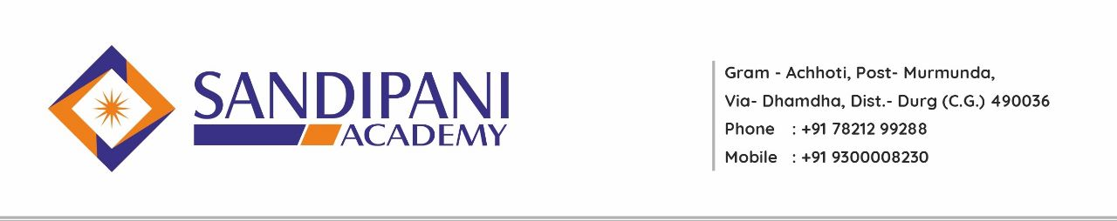
Sandipani Academy, Achhoti
Academic Calendar
B. Ed First Semester
Session 2022-2023
Date: - 20/06/2022
Month | Activities Academic | Co-curricular Activities
August 2022 | Admission Process
September 2022 | Introduction of Syllabus  Commencement of Classes  Explanation of B.Ed.- I Semester Curriculum  One Unit of Each Subject including Pedagogical Subjects  Teaching Aid Preparation  Unit Test | Assembly ( NEWS Reading, Thought of the Day)  Induction program for students  Life skill program every Saturday  National Days Celebration  Guest Lecture  Co-curricular Activities
October 2022 | One Unit of Each Subjects including  Pedagogical Subjects  Providing Assignment  Unit Test | Assembly ( NEWS Reading, Thought of the Day)  Life skill program every Saturday  National Days Celebration  Guest Lecture  Co-curricular Activities
November 2022 | One Unit of Each Subjects including Pedagogical Subject  Students’Seminar Presentation by PPT  Unit Test  Community Activity | Assembly ( NEWS Reading, Thought of the Day)  Life skill program every Saturday  National Days Celebration  Guest Lecture  Co-curricular Activities
December 2022 | One Unit of each subjects  Including Pedagogical Subjects  Assignments Submition  Practicum – 1 Teaching Aid Preparation & submission  Unit Test | Assembly ( NEWS Reading, Thought of the Day)  Life skill program every Saturday  Seminar by students  National Days Celebration  Guest Lecture  Co-curricular Activities
January 2023 | One Unit of each subjects including Pedagogical Subjects | Assembly ( NEWS Reading, Thought of the Day)  Life skill program every Saturday  National Days Celebration  Guest Lecture  Co-curricular Activities
February  2023 | - Model Examination  - University Examination | Annual Sports Day Celebration

Note:
1) Discussion on School Education system.
2) Movie Review
3) Yoga / Meditation Saturday
4) Seminar by students
5) Language Lab for students

PRINCIPAL/H.O.D.

